CSE 3055 DATABASE SYSTEMS PROJECT
AIRPORT



Ertuğrul Sağdıç – 150116061
Eray Ayaz – 150116053

About The Project
In this project step, we are designing an airport database system, which can applied to web application. Our aim is to make easier manage for flights in airports, reservation to car park, and management of car park and apron, list of stores in airport, and employees of airport.

Data & Requirement Analysis
The database consist of tables such as; airport, vehicle, car, airport vehicles, plane, car park, apron, airport store, supplier, supplies, person, pilot, pilot certificate, passenger, ticket, employee, employee certificate, technician, traffic controller, manager, emergency service, flight cargo flight, passenger flight.
- Airport identified with its unique airport id, name of the airport, and city where its located.
- Vehicles are identified with their unique vehicle id, model and color. There are three types of vehicles, which are car, airport vehicle, and plane.
  - Cars are identified with their unique plate number, and daily price.
  - Airport vehicles are identified with their unique plate number and their type.
  - Planes are identified with their unique Plane id, capacity, type of plane, hourly price, and daily price.
- Car Park identified with unique space number, arrival time and leaving time. Cars and airport vehicles can be park into car park. There can be more than one car or airport vehicle in car park. If an airport vehicle parks in car park, there will be no charge. There can be more than one car park in the airport.
- Also, apron identified with unique apron number, arrival time and leaving time. Planes can park to apron. There can be more than one planes in the apron There can be more than one apron in the airport.
- Airport stores are identified with their unique block number, name and contract date. There can be more than one airport store in the airport.
- Suppliers are identified with their supplier id, their names, address which include district and city, and phone number. There can be more than one supplier, which supplies to airport store.
- Supplies table is an associative entity, which takes unit price and product type.
- Persons in the database system are identified with their TCKN, name, address which includes street and city, and phone number. There can be more than one phone number. There are three types of person, which are pilots, passengers and employees. Employees and pilots can be passenger.
  - Pilots are identified with their unique pilot id. There must be a certificate of pilot. there is pilot certificate associative entity, to keep pilot’s certificate in database system
  - Pilot certificates are identified with their unique certificate id, and date which has completed.
  - Passengers are identified with their gender and luggage weights. There must be a ticket of passenger. There can be more than one passenger flights.
  - Tickets are identified with their unique ticket id, price and type. There can be more than one ticket.
  - Employees are identified with their unique employee id, salary and date of hiring. There are four type of employees, which are technician, traffic controller, manager, emergency service. In addition, there must be certificate of employees. There is employee certificate associative entity, to keep employee’s certificate in database system.
  - Employee certificates are identified with their unique certificate id, and date which has completed.
    - Technicians identified with their field that they are working.
    - Traffic controllers identified with their location that they are working.
    - Emergency services are identified with their type and emergency number.
    - Managers identified with their department that they manage. There must be at least one or more manager for each employee type.
- Flights are identified with their unique flight id, date, time, goes to, and comes from. There are two types of flights, which are cargo flights and passenger flights. There must be more than one flight in the airport.
  - Cargo flights are identified with number of cargo that plane take.
  - Passenger flights identified with number of seats, and number of cabin attendants in the plane. There must be more than one passenger who flies with passenger flights.

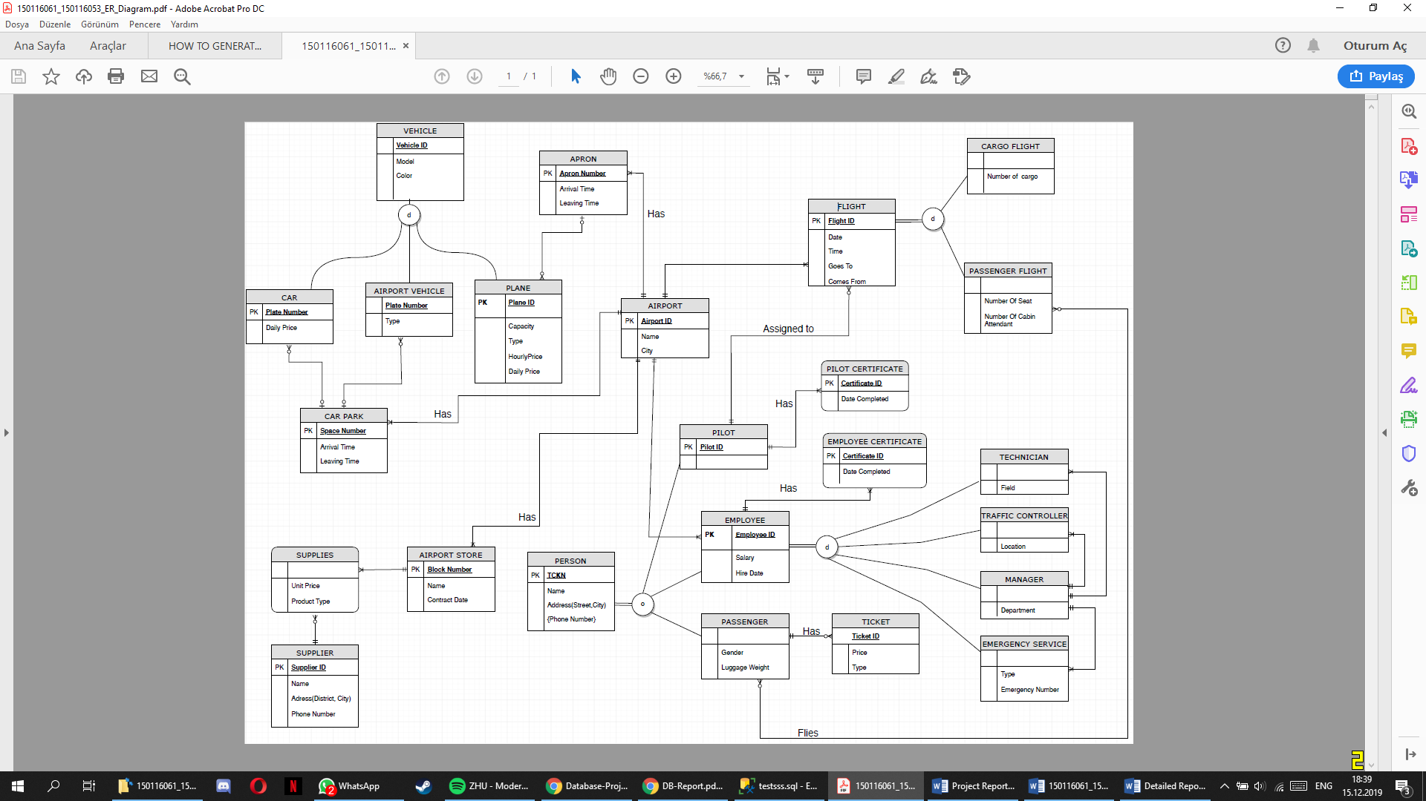
E-R Diagram

Database Diagram
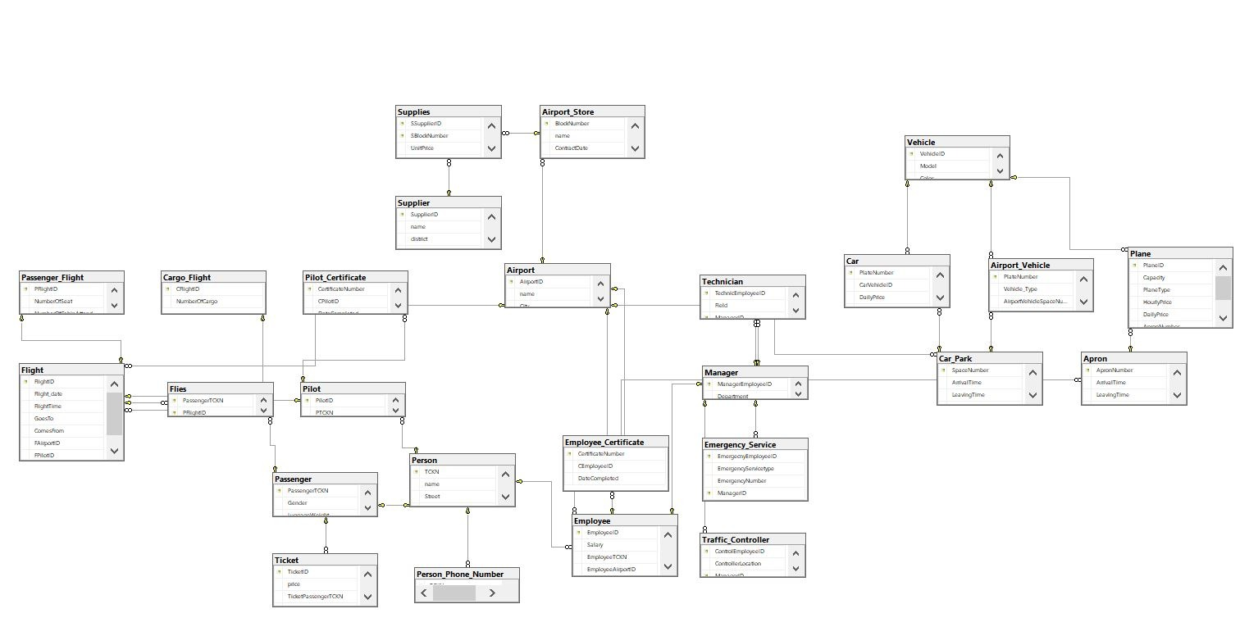
Information about Tables and Attributes
- AIRPORT
Airport
Attribute | Data Type | Primary Key | Foreign Key
AirportID | VARCHAR(3) | ✔
name | VARCHAR(30)
City | VARCHAR(20)

- VEHICLE TABLE
Vehicle
Attribute | Data Type | Primary Key | Foreign Key
VehicleID | INT | ✔
Model | INT
Color | VARCHAR(15)

- CAR
Car
Attribute | Data Type | Primary Key | Foreign Key
PlateNumber | VARCHAR(11) | ✔
CarVehicleID | INT |  | ✔
DailyPrice | MONEY
CarSpaceNumber | INT |  | ✔

- AIRPORT VEHICLE
Airport_Vehicle
Attribute | Data Type | Primary Key | Foreign Key
PlateNumber | VARCHAR(11) | ✔
Vehicle_Type | VARCHAR(30)
AirportVehicleSpaceNumber | INT |  | ✔
AirportVehicleID | INT |  | ✔

- PLANE
Plane
Attribute | Data Type | Primary Key | Foreign Key
PlaneID | VARCHAR(7) | ✔
Capacity | INT
PlaneType | VARCHAR(30)
HourlyPrice | MONEY
DailyPrice | MONEY
ApronNumber | INT |  | ✔
PlaneVehicleID | INT |  | ✔

- CAR PARK
Car_Park
Attribute | Data Type | Primary Key | Foreign Key
SpaceNumber | INT | ✔
ArrivalTime | TIME
LeavingTime | TIME
ParkingLotAirportID | VARCHAR(3) |  | ✔

- APRON
Apron
Attribute | Data Type | Primary Key | Foreign Key
ApronNumber | INT | ✔
ArrivalTime | TIME
LeavingTime | TIME
ApronAirportID | VARCHAR(3) |  | ✔

- AIRPORT STORE
Airport_Store
Attribute | Data Type | Primary Key | Foreign Key
BlockNumber | INT | ✔
name | VARCHAR(15)
ContractDate | DATE
StoreAirportID | VARCHAR(3) |  | ✔

- SUPPLIER
Supplier
Attribute | Data Type | Primary Key | Foreign Key
SupplierID | INT | ✔
name | VARCHAR(20)
district | VARCHAR(15)
city | VARCHAR(15)

- SUPPLIES
Supplies
Attribute | Data Type | Primary Key | Foreign Key
SSupplierID | INT | ✔ | ✔
SBlockNumber | INT | ✔ | ✔
UnitPrice | INT
ProductType | VARCHAR(20)

- PERSON
Person
Attribute | Data Type | Primary Key | Foreign Key
TCKN | NUMERIC(11,0) | ✔
phoneNumber | NUMERIC(11,0)
Street | VARCHAR(15)
City | VARCHAR(15)

- PERSON PHONE NUMBER
Person_Phone_Number
Attribute | Data Type | Primary Key | Foreign Key
TCKN | NUMERIC(11,0) | ✔ | ✔
phoneNumber | NUMERIC(11,0)

- PILOT
Pilot
Attribute | Data Type | Primary Key | Foreign Key
PilotID | INT | ✔
PTCKN | NUMERIC(11,0) |  | ✔

- PILOT CERTIFICATE
Pilot_Certificate
Attribute | Data Type | Primary Key | Foreign Key
CertificateNumber | INT | ✔
CPilotID | INT |  | ✔
DateCompleted | DATE

- PASSENGER
Passenger
Attribute | Data Type | Primary Key | Foreign Key
PassengerTCKN | NUMERIC(11,0) | ✔ | ✔
Gender | CHAR
LuggageWeight | INT |  | ✔

- TICKET
Person
Attribute | Data Type | Primary Key | Foreign Key
TicketID | VARCHAR(6) | ✔
price | MONEY
TicketType | VARCCHAR(20)
TicketPassengerTCKN | NUMERIC(11,0) |  | ✔

- EMPLOYEE
Employee
Attribute | Data Type | Primary Key | Foreign Key
EmployeeID | INT | ✔
Salary | MONEY
EmployeeTCKN | NUMERIC(11,0) |  | ✔
EmployeeAirportID | VARCHAR(3) |  | ✔

- EMPLOYEE CERTIFICATE
Employee_Certificate
Attribute | Data Type | Primary Key | Foreign Key
CertificateNumber | INT | ✔
CEmployeeID | INT |  | ✔
DateCompleted | DATE

- TECHNICIAN
Technician
Attribute | Data Type | Primary Key | Foreign Key
TechnicEmployeeID | INT | ✔
Field | VARCHAR(20)
ManagerID | INT |  | ✔

- TRAFFIC CONTROLLER
Traffic_Controller
Attribute | Data Type | Primary Key | Foreign Key
ControlEmployeeID | INT | ✔
ControllerLocation | VARCHAR(20)
ManagerID | INT |  | ✔

- EMERGENCY SERVICE
Emergency_Service
Attribute | Data Type | Primary Key | Foreign Key
EmergencyEmployeeID | INT | ✔
EmergencyServiceType | VARCHAR(20)
EmergencyNumber | NUMERIC(3,0)
ManagerID | INT |  | ✔

- MANAGER
Manager
Attribute | Data Type | Primary Key | Foreign Key
ManagerEmployeeID | INT | ✔ | ✔
Department | VARCHAR(10)
- FLIGHT
Flight
Attribute | Data Type | Primary Key | Foreign Key
FlightID | VARCHAR(7) | ✔
Flight_date | DATE
FlightTime | TIME
GoesTo | VARCHAR(3)
ComesFrom | VARCHAR(3)
FAirportID | VARCHAR(3) |  | ✔
FPilotID | INT |  | ✔

- FLIES
Flies
Attribute | Data Type | Primary Key | Foreign Key
PassengerTCKN | NUMERIC(11,0) | ✔ | ✔
PFlightID | VARCHAR(7) | ✔ | ✔

- CARGO FLIGHT

Cargo_Flight
Attribute | Data Type | Primary Key | Foreign Key
CFlightID | VARCHAR(7) | ✔ | ✔
NumberOfCargo | INT

- PASSENGER FLIGHT
Passengger_Flight
Attribute | Data Type | Primary Key | Foreign Key
PFlightID | VARCHAR(7) | ✔ | ✔
NumberOfSeat | INT
NumberOfCabinAttendant | INT

1.Indices
- We do not need to create a index because when we are creating a table and assign a primary keys and foreign keys also we are creating an indices.
2.Constraints
- We have name constraints on Airport table. Because if someone want to create a airport with the same name we should block this. Every airport name should be unique.
- Our second constraints is about Airport Store table. İf someone want to open a new store in airport with the same name again we should block this. Actually it can be happen but it will be awkward for our Airport design.

3.Triggers
- Insert Supplier → SuppIns
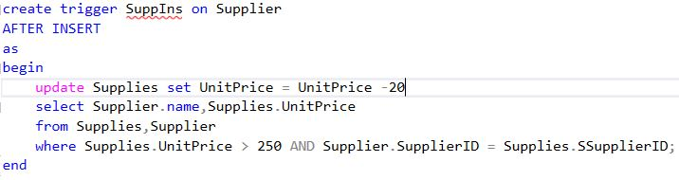
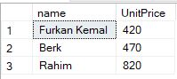
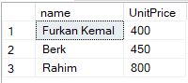

This trigger will do subtraction when the user enter the new supplier. Substraction is valid for prices higher than 250. Because when you add a new supplier in the real life there will be big competition between the supplier. Then the supplier make lower prices to sell more items.
- Delete Cargo Flight → flights
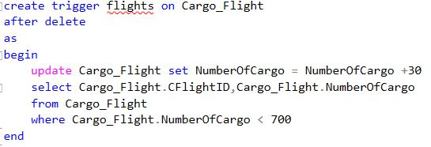

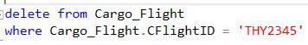
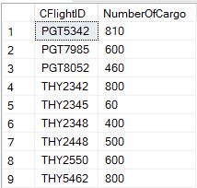
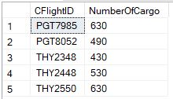

This trigger will do addition when the user delete the cargo flight. Addition is valid for number of cargo less than 700. If you delete the cargo flight then some cargos do not have a flight because of that we add the a little bit cargos to other cargo flights.

4.View

- View of the Park
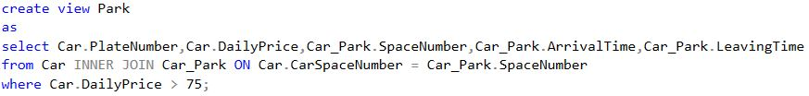
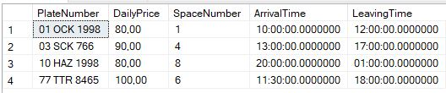

This view shows the detail about car which is parked and daily price less than 75. We get the plate number and daily price of car and space number,arrival time and leaving time of the car which is parked.

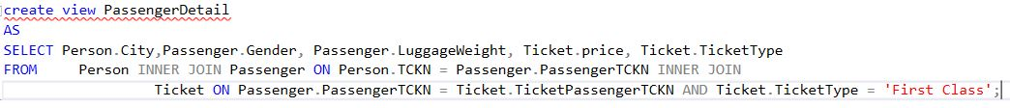
- View of the Passenger Detail

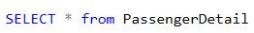
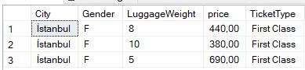

This view shows the detail of the passenger and about his ticket if the ticket type is first class. We get from this view city name, gender and luggage weight of the passenger. Also we get information about price and type of ticket.

- View of Airport Stores
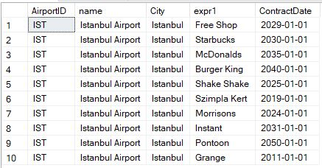

This view shows the information about airport stores. We get id,name and city of the airport and also we get the name and contract date of the airport stores.

4.Stored Procedures
- SalaryEmp → Stored Procedure
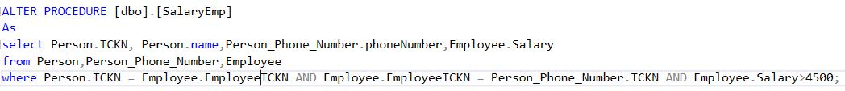
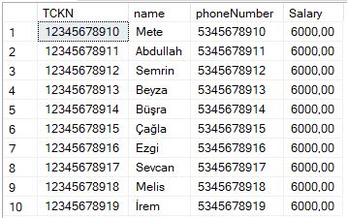

This procedure will show the detail about person, his/her phone number and if his/her salary higher than 6000 then it will show the salary of the person.

- CarDetail → Stored Procedure
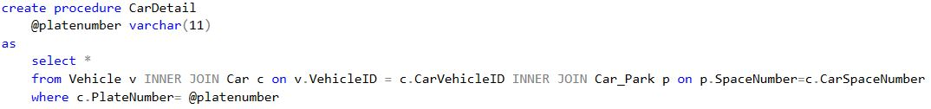

This procedure will shows every detail about the car when user execute this procedure with the plate number of the car.

